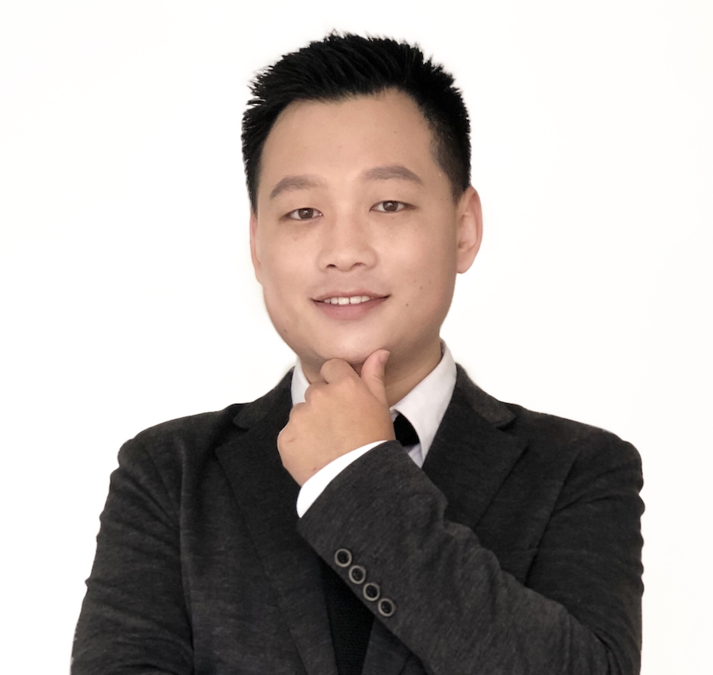 | Deli Qiao  DevOps / Platform Engineer  14 Years Infrastructure Automation · Multi-Cloud Platform Engineering  Shenzhen, China · +86 15522013699 · qiaodeli111@126.com · github.com/qiaodeli111

Core Strengths
14 Years DevOps/SRE | IaC System Architecture
Full-Stack Automation  Built full-stack infrastructure automation from scratch covering bare-metal (BMAAS), private cloud, and multi-cloud environments | Patents & Software Copyrights  Developed one-stop DevOps toolbox with Invention Patent (CN121635905A) and Software Copyright (2025SR2538156)
Localization Engineering  Completed full-chain localization for Anolis OS/UOS/OpenEuler, supporting x86/ARM64/C86 triple-architecture delivery | Professional Certifications  Certifications: AWS SAA · CKA · RHCE · Azure Admin · PMP
Key Achievements
ZFS Storage Performance Tuning | IOPS 230k → 800k (3.5× improvement)
Image Factory Pipeline Efficiency | Zero failures 30+ days, 3.2× efficiency gain
Private Cloud Platform Delivery | Bottom-up HA architecture, 5+ customer sites
Parallel Project Coordination | 7 projects running simultaneously
Operations Efficiency (IBM Era) | Efficiency +50%, Quality +90%, Deploy time -80%
Patents & Software Copyrights
Invention Patent | JetDev Operations Toolchain Core Architecture · CN121635905A
Software Copyright | JetDev One-Stop DevOps Toolbox Platform · 2025SR2538156
Tech Stack
CLOUD PLATFORMS | CloudStack · AWS · Alibaba Cloud · Huawei Cloud · CT Cloud · Proxmox VE
CONTAINER ORCHESTRATION | Kubernetes · Docker · Helm · Harbor · JFrog Artifactory
IAC AUTOMATION | Terraform (in-house Provider) · Ansible · Packer · Tinkerbell · cloud-init
STORAGE | ZFS · DRBD · DRBD-Reactor · Linstor · LVM
OBSERVABILITY | Grafana · Prometheus · Alertmanager · Loki · Fluentd · Zabbix
SECURITY & COMPLIANCE | Vault · Nessus · Lynis · Consul ACL · SSL/TLS · Trivy
CI/CD & GITOPS | GitLab CI · ArgoCD · Helm · Goss · Jenkins · Ansible Tower
OPERATING SYSTEMS | Ubuntu · Anolis OS · UOS · OpenEuler (x86/ARM64/C86)
LANGUAGES | Go · Python · Shell/Bash · HCL
Personal Projects
ResumeForge - Brand-Grade Resume Generator | https://github.com/qiaodeli111/ResumeForge Apr 2026
• Built multi-theme resume generation system from scratch with 50+ brand design styles (Apple/Tesla/Stripe/Vercel etc.)
• YAML-driven content management, one-click generation of HTML/PDF/DOCX formats, bilingual support
• Modular architecture: content-style separation, hot-pluggable themes, extensible brand customization
• Tech stack: Python, Jinja2 templating, python-docx, Chrome Headless PDF rendering
• Full style resume board for me: https://resume.dellyqiao.com

Work Experience
ShenZhen JetIO Technology Co., Ltd. Oct 2024 – Present | Shenzhen
DevOps Team Lead
Coordinating 7 parallel projects (BMAAS/Terraform/Image Factory/CloudStack/K8s/IT Support/JetDev), leading architecture decisions and tech selection, delivering 5+ customer sites.
▸ Kubernetes Platform Engineering
• Built K8s on CloudStack from scratch: hybrid architecture (control plane on VMs + workloads on K8s), etcd HA, Calico CNI, CSI integration
• Established ArgoCD GitOps conventions: Git repo separation, Helm versioning, environment promotion flow, migrated to 'Git PR is deployment'
• Core service migration: JumpServer Helm Chart migration (Cert-Manager SSL); JFrog Artifactory HA architecture design
▸ CloudStack Private Cloud
• ZFS performance tuning: IOPS 230k → 800k; fixed DRBD heartbeat parameters for 7×24 stability
• Troubleshot critical issues: VM creation failure, migration interruption, read-only mode trigger, with root cause analysis and patch submission
• Observability: Alert response reduced from hours to minutes; launched Grafana capacity dashboards
▸ BMAAS Bare-Metal Automation
• Extended Tinkerbell/HookOS: added Rescue mode, redfish-batch-ISO tool
• cloud-init zero-touch provisioning: hostname/MTU/disk auto-configuration; x86/ARM64/C86 full-architecture delivery
▸ Image Factory (Packer)
• 5 OS × 3 architecture full-matrix builds; integrated Goss/Lynis/Trivy automated testing
• Localization enablement: Anolis OS on ARM (ZFS/DRBD HA integration), UOS on Hygon C86
• Pipeline zero failures for 30+ days, efficiency improved 3.2×
▸ JetDev Toolchain (Patent & Copyright)
• Built one-stop DevOps toolbox: integrated Ansible/Terraform/Packer/GitLab Runner
• Ansible Role scaffold generation time reduced by 80%
• Filed Invention Patent CN121635905A, Software Copyright 2025SR2538156
• Adopted by ops and testing teams

Kyndryl Shenzhen (IBM Spin-off) Sep 2021 – Aug 2024 | Shenzhen
SRE Engineer (Toolchain) · Technical Lead
Work identical to IBM: maintained Software Defined Environment (SDE) platform, drove transformation from traditional ops to automated operations; served as Technical Lead for solution design, task allocation, and cross-region collaboration.

IBM Shenzhen Mar 2017 – Sep 2021 | Shenzhen
SRE Engineer (Toolchain) · Technical Lead
Maintained Software Defined Environment (SDE) platform, drove transformation from traditional ops to automated operations; served as Technical Lead for solution design, task allocation, and cross-region collaboration.
▸ Automated Operations System
• Transformed team from "manual + scripts" to "local dev + automated build/test + one-click deploy/rollback"
• Team ops efficiency +50%, quality +90%, human errors nearly eliminated
• Customer app deployment time -80%, change request handling time -50%
• Managed full DevOps toolchain: Chef/GitLab/Jenkins/Ansible Tower/UCD
▸ AWS Architecture Consulting
• Designed global architecture for North America customer: ECS → EKS cluster migration, Global Accelerator for traffic offload
• Separated storage and database layers, pre-peak horizontal scaling, resolved cross-region latency and high costs
▸ Team & Achievements
• 6 consecutive years of "Exceed Expectation" annual performance rating
• Managed 4-10 person cross-cultural team (China/India), led technical interviews and capability building

Tianjin NNIT Technology Co., Ltd. May 2016 – Mar 2017 | Tianjin
Change Service Delivery Manager (ITIL / GxP Compliance)

▸ Change Management
• Reviewed RFC change requests: business need, risk assessment, execution plan, rollback plan - end-to-end governance
• GxP (Good Laboratory Practice) compliance document audit, ensuring completeness and compliant signatures
• Rebuilt change management workflow with Excel templates + automation scripts, reducing workload by 80%
• Built monthly productivity report automation pipeline, improving management efficiency and PIR quality

DXC Technology (formerly CSC) Jun 2012 – May 2016 | Tianjin
WebHosting Team Lead / Operations Engineer
Provided comprehensive middleware and JavaEE enterprise application operations for AIA across multiple Asian regions.
▸ Team Leadership & Automation
• Led 4-person international team (China/India, promoted to Team Lead in Sep 2014), automation coverage increased from 10% → 50%
• Mentored India Offshore team members, built high-performance service platform, received customer commendation
▸ Key Projects
• Led multi-site data center migration, website partition, and new system establishment
• Led IBM WAS 6 → WAS 8 middleware cross-version upgrade migration
• SSL certificate management, disaster recovery testing, Zabbix monitoring system maintenance
• Developed automation scripts, team efficiency improved by 20%
Certifications
AWS SAA (Nov 2022) CKA (Aug 2021) RHCE (Jun 2022) Azure Admin (Apr 2022) Alibaba Cloud ACP (Jul 2021) PMP (Nov 2017) ITIL® Foundation (Feb 2017)
Education
Tiangong University 【Double First-Class】 2008 – 2012
Bachelor of Software Engineering

